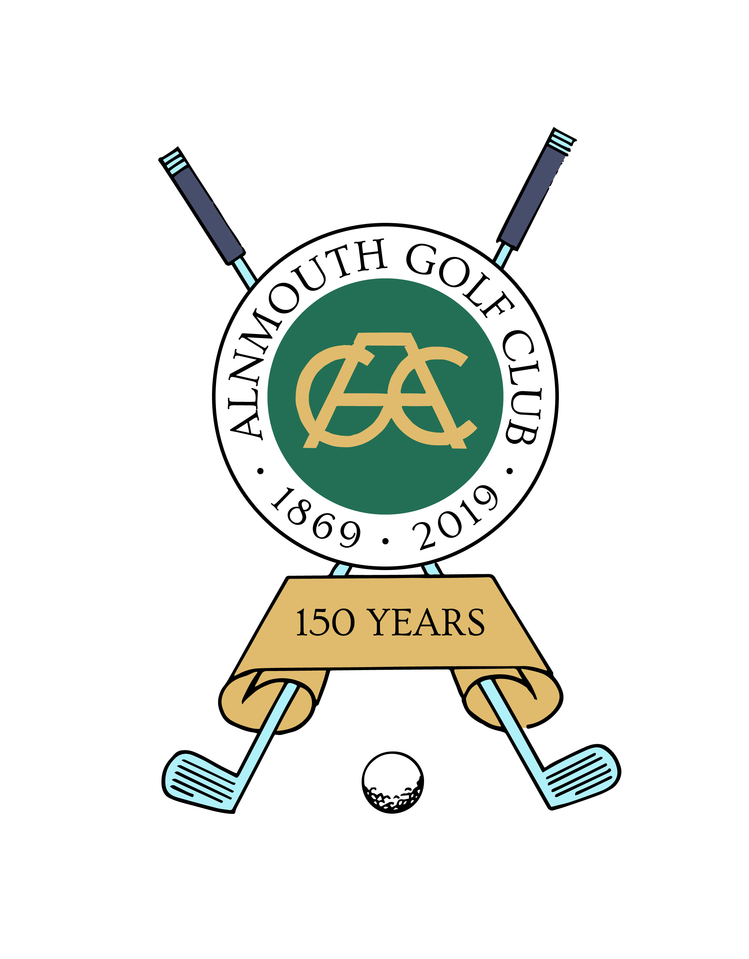
CHARITY GOLF DAY
Amble & Warkworth Wednesday 10th July, 2019
ENTRY FORM

Please complete and return to:
Rotarian David Bell - Walnut Cottage, 4, The Old Byre, Eastfield, Morpeth NE65 0YE
together with your cheque for £100 in favour of “Rotary Club of Amble and Warkworth”.

Your Team Title: …………………………………………………………………………………………………………………………..….
Team Members:
Mr/Mrs/Ms | Name | Rotary Club/Golf Club/ Organisation | Current Handicap

Please tick which applies:
We will be able to start at any time between 8am and 3pm
We would prefer to start between 8am and 12 noon
We would prefer an afternoon start time
Name of Team Captain (Block capitals please) ________________________________________________________

Signed ____________________________________________________Date _______________________________

Address:

Post Code:

Contact email address: Telephone No:

SPONSORSHIP PACKAGE (Please tick if either apply and we will contact you).

I would like to:

Sponsor a hole

Advertise in the Event Brochure £100 for full page advert, £50 half page (other options pro rata)

Rotary Amble and Warkworth promises to respect the confidentiality of any personal data you share with us. We will make every effort to keep it safe and protect your privacy. We pride ourselves on our honesty and openness and will always be clear how, when and why we collect and process personal information; we promise we will never do anything with personal details that one wouldn’t reasonably expect as a participant in this competition. Comunication between us and competitors is crucial, and personal data allows us to manage that process and to provide the information and service that you are entitled to. All data is subject to our GDPR Privacy Notice, which is available in full on our website. Please contact us if you do not wish us to hold your personal data.
