The Development of Rotary Way
In 2004 the Rotary Club of Amble and Warkworth (RC of A&W) successfully applied to Northumberland County Council (NCC) to adopt the section of the A1068 which connects Amble and Warkworth and rename it Rotary Way. This road is bordered on one side by the River Coquet and its estuary. It teams with wildlife ranging from seabirds to seals and attracts many “twitchers” and photographers. Between the river and the highway are a cycle track/footpath and a two metre high raised verge. On the other side of the highway is an expanse of verge, varying in width from four to ten metres. It is (was) a neglected weed infested wilderness.
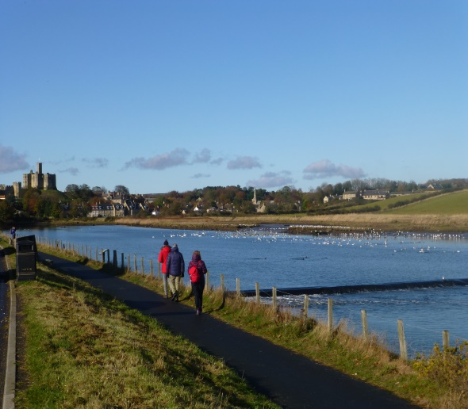
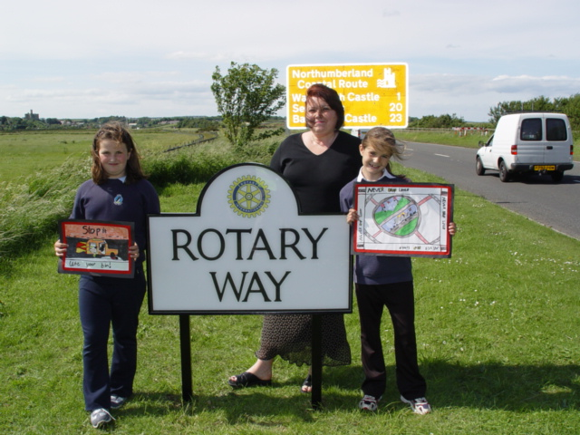
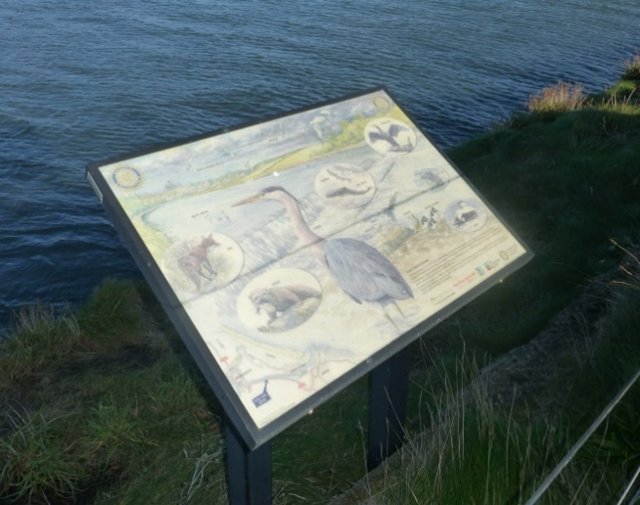
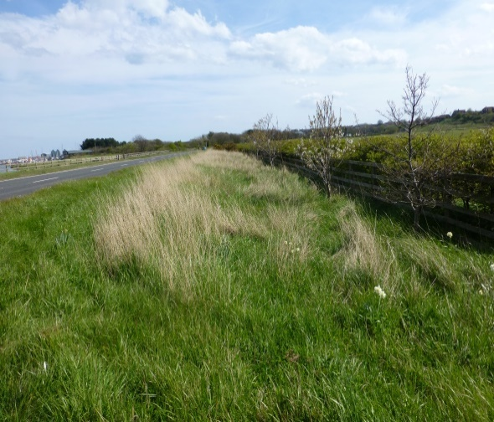
Initially the adoption resulted in a “Rotary Way “sign and an information board being erected to illustrate the wildlife commonly seen in the estuary.

In 2012 the RC of A&W decided to make the development of Rotary Way an ongoing project. Many aspects of the way were identified as being in need of attention and it was felt that developing The Way would enhance the profile and reputation of the club, would help us involve many other organisations in the work of the Club and improve the profile of Amble and Warkworth. Both these places are tourist attractions – Amble with its beaches, yachting marina and harbour - Warkworth with its Norman Castle (60,000 visitors a year). Church and picturesque dwellings and riverside.

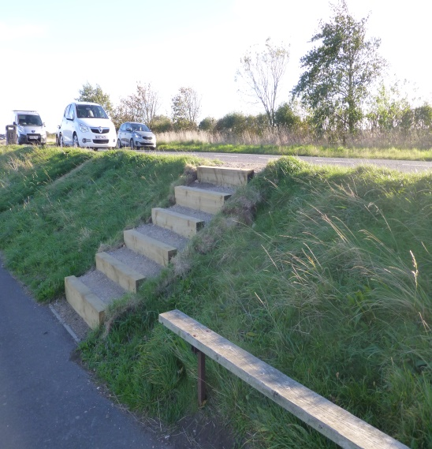
The issues on The Way which it was felt needed enhancement were:- the terrible road surface, the unkempt lay-byes, the uncared for cycle track, the collapsing riverside fence, cluttered highway signage, the rotten wooden planters at each end of Rotary Way, the wide unkempt grass verge and the lack of access from the lay-byes to the footpath below.
To bring about these changes we had to engage with not only our Rotary District 1030, Inner Wheel and Interact but also with Northumberland County Council, The North East Branch of the Area of Outstanding Natural Beauty, Northumberland Estates (the Duke of Northumberland), the local councils of Amble and Warkworth, county and local ecologists, beekeepers, farmers, seed providers and machine hire firms and of course the local community.
We applied successfully for grants from the Rotary District (in 2004 and 2018), Community Foundation Northumberland Grants Fund, the Sir James Knott Trust, the local Councils of Amble and Warkworth and the Grass Roots Community Foundation Fund. Our Rotary Club also raised charitable funds locally. To help with these grant applications we formed a charitable arm of our Rotary Club “The Coquet Community Trust” which we use to apply, as a charitable organisation, to grant giving bodies, most of which will support only charitable organisations. In total we have raised approximately £10,000 which has been used to change and maintain certain aspects of Rotary Way.
We could not have achieved so much without the engagement with and co-operation of NCC. When The Way was chosen as a route for the procession of the Olympic torch in 2012, we found out that there were grants available to councils to enhance these much-publicised routes and NCC successfully applied for a grant which enabled them to resurface the highway, the lay-byes and the drains to a very high standard. Our research also found that the footpath along the riverside of Rotary Way was a designated children’s’ school route. We pointed out to Northumberland estates (the Duke of Northumberland who owns the river and its banks) that the fence along Rotary Way was unsafe and children had unhindered access into the river and so, following pressure from NCC, one kilometer of the fence was upgraded and repaired.
Through their small grants scheme, The councils of Amble and Warkworth agreed to replace the old rotting planters at each end of Rotary Way with stone planters and both Warkworth and Amble in bloom agreed to look after the planters and change the planting within them three times per year. After extensive negotiation with NCC they agreed to develop build and supply a sign which did not actively advertise Rotary but which nevertheless is characteristic of Rotary. This sign is now used on the several Rotary Ways in Northumberland.
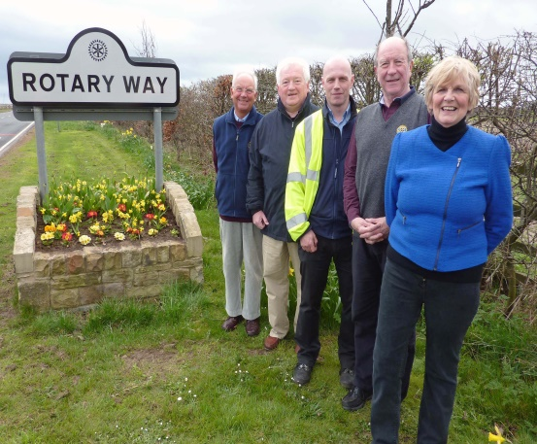
After a contribution from The RC of A&W (and some others) to NCC steps have been built which connect the lay-bye above (commonly known as “The Rotary lay-bye”) to the footpath below.

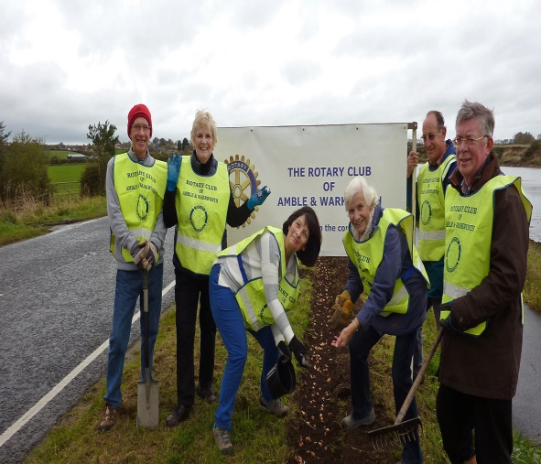
The Rotary Club has planted 11,500 purple crocus corms along the raised verge on the river side of the Way. Passersby are always fascinated to hear about “End Polio Now”.
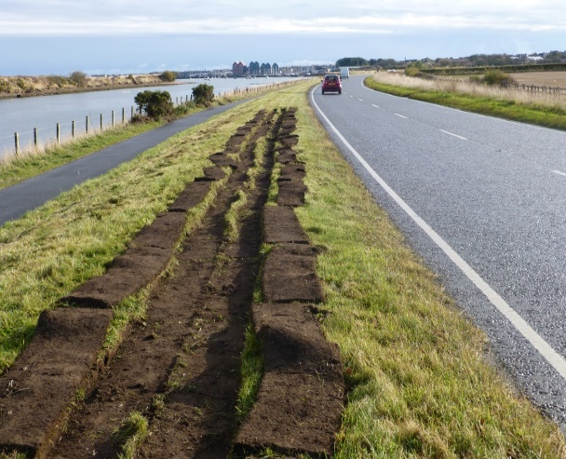
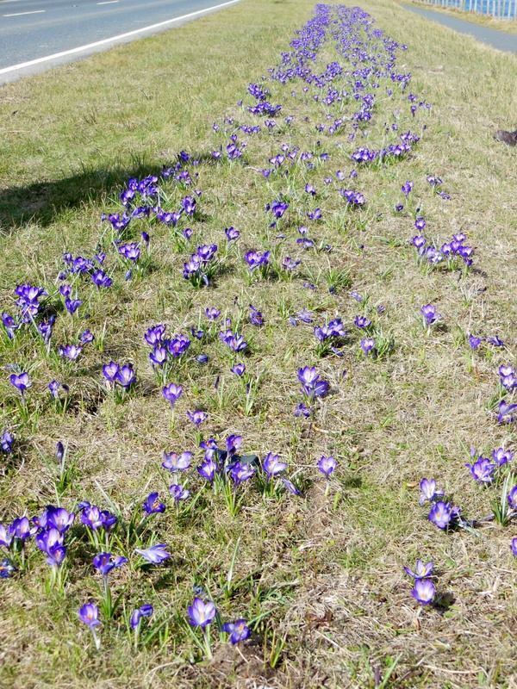
Many community volunteers helped with the planting
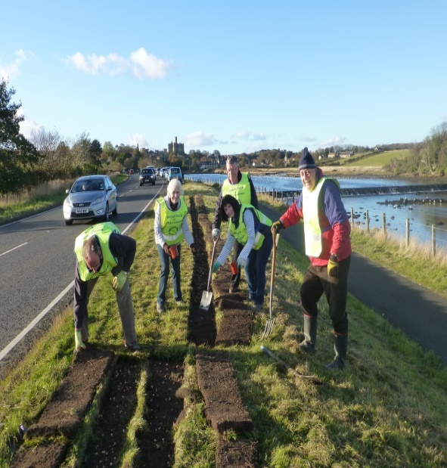
We have embarked on changing the neglected verges on the landward side of the highway into wild flower meadow areas. This has proved expensive (seeds costs £100 per gram) and clearing the ground in preparation for planting (mowing, spraying, harrowing, seeding and protecting) is labour intensive. Maintenance is also labour intensive as the wild-flowers, once spent, have to be cut with a cross cutting blade, shaken, baled and removed.
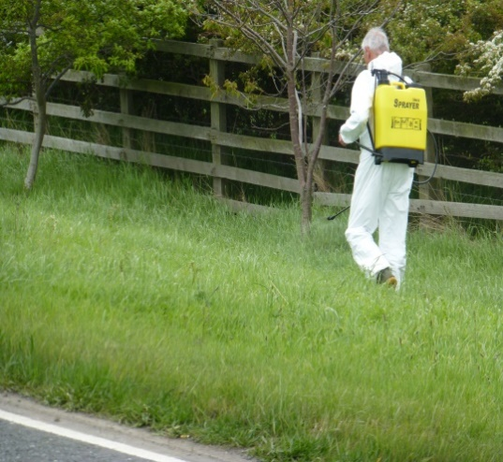
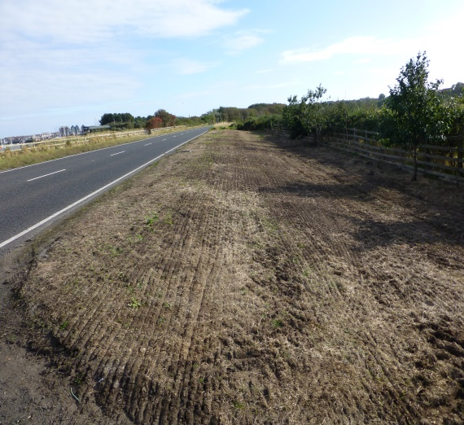
Before preparation Spraying after mowing

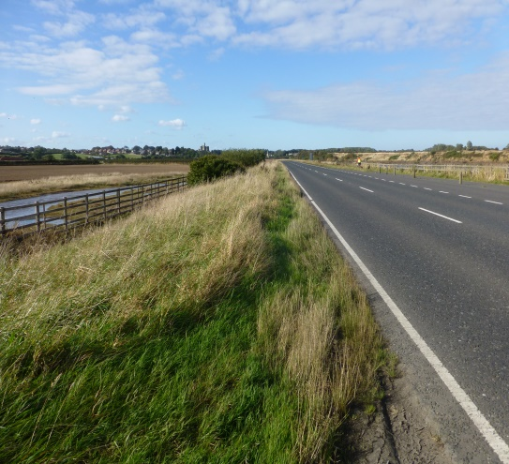
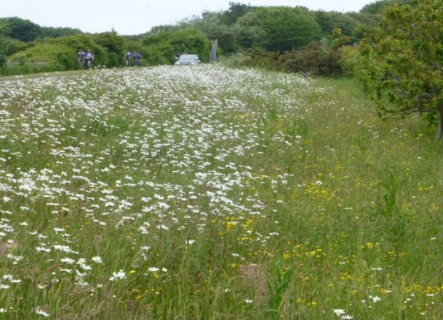
After Planting Flowering
Our aim is to plant 400 metres of wild flower meadow at each end of Rotary Way. We feel this is an achievable and maintainable target.
We have conducted innumerable litter picks along each side of The Way and have advertised our presence and achievements on our Facebook and Website pages to some acclaim. The addresses are given in the submission paperwork.
We estimate that over the years we have donated at least five hundred hours of volunteer time, taking into account:-
- grant applications,
- meetings,
- presentations,
- charm offensives
- physical graft.
One can have little idea how many meetings, setbacks, changes of track and frustration it took to get NCC to come up with our “Rotary Way” signs!
And finally, has it been worth it? Well when we were taking the photos of our wild flower areas, eighteen months after they had been planted, we came across a juvenile pheasant hunkered down in the wild flowers about two feet from the edge of the busy highway. He was completely oblivious to the traffic and to the photographer wandering about trying to identify the many species of wildflowers – so we took his picture.
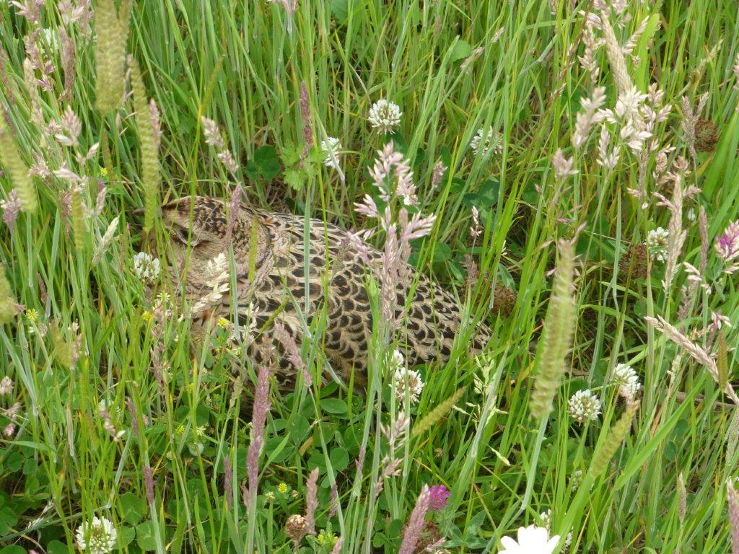
……and here he is.

Rotary prepared the final planned stretch of land for planting in November 2020:
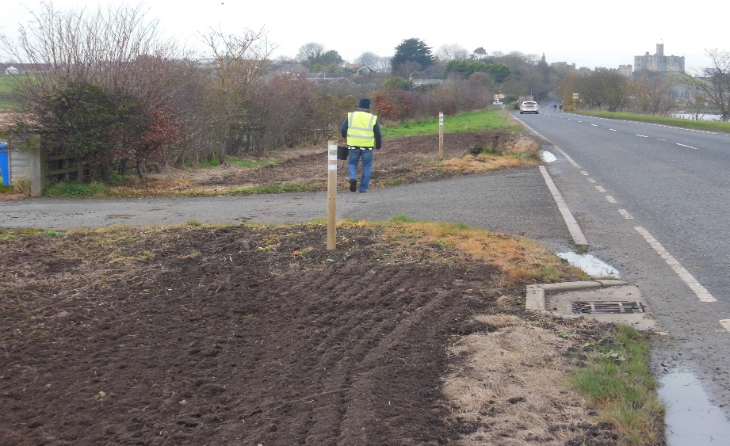
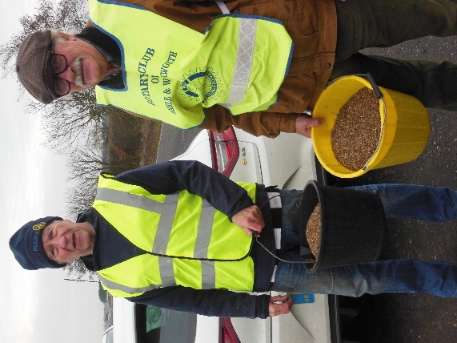

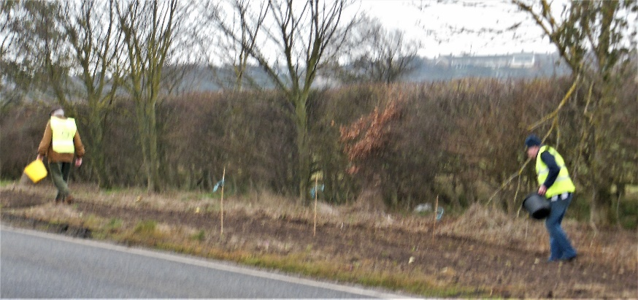
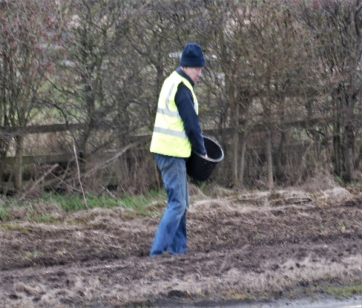
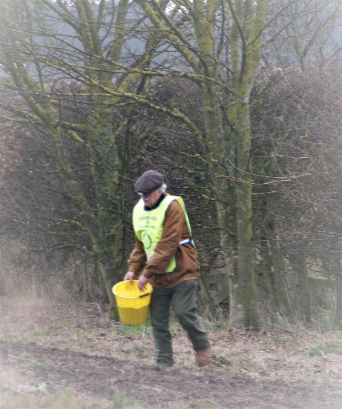
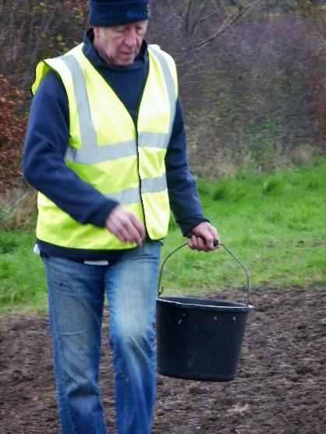
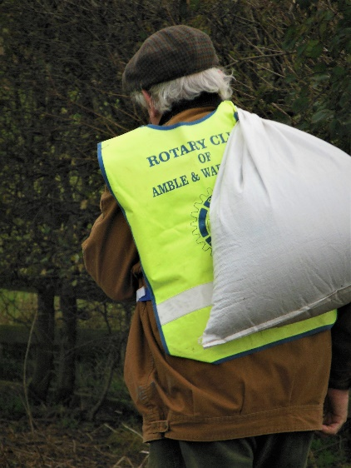
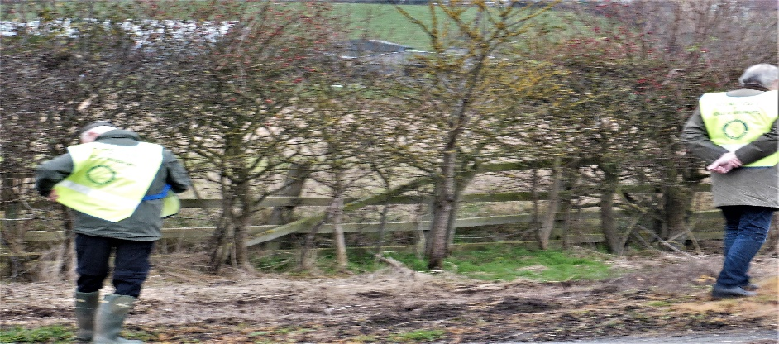

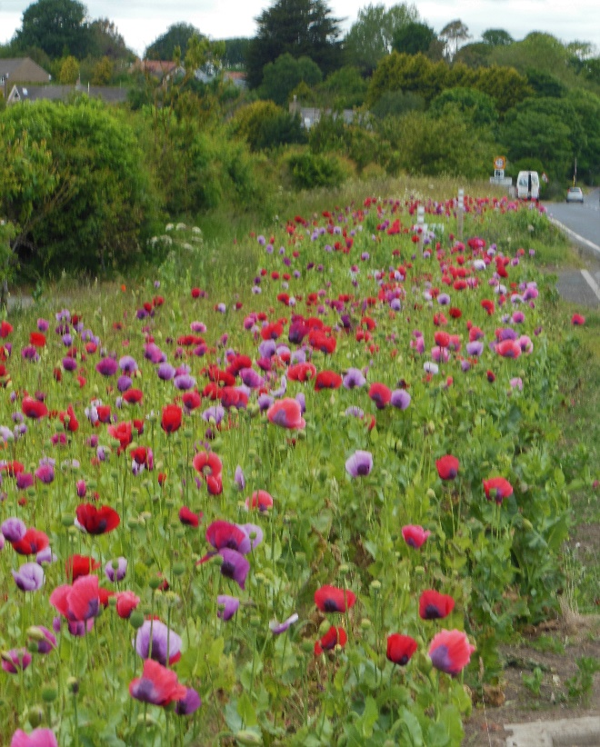
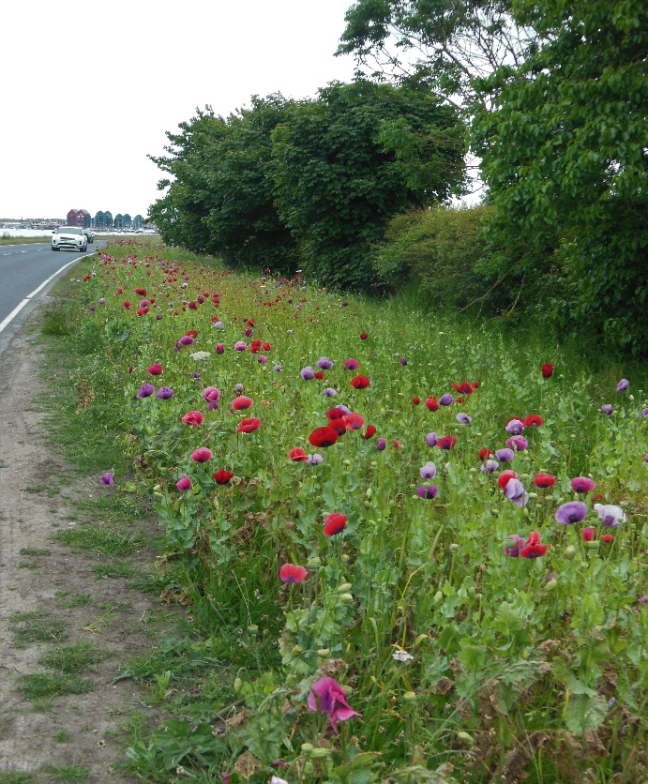
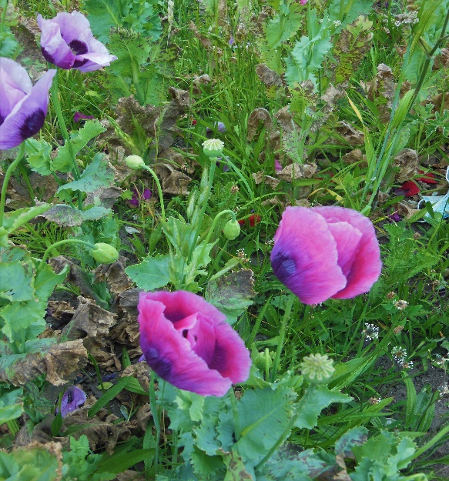
Finally, in July 2021:
